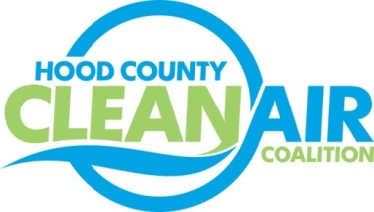
Meeting: Wednesday, April 6, 2016
American Town Hall
220 N. Travis Street, Granbury, Texas 76048
8:30-10:30 a.m.

Agenda

- Call Meeting to Order
- EPA Updates – Carrie Paige
- Regional Updates – Michelle McKenzie
  - Air Quality Funding Opportunities for Vehicles
  - Clean Air Action Day - June 24, 2016
- Local Updates – Michelle McKenzie
  - Review of March Meeting Summary
  - Review of Projects
    - Monthly Budget Review for February
    - Status of Projects FY 16/17
  - Reports
    - March Ozone Update
    - Air North Texas
    - EPA Ozone Advance Guidance Revisions Webinar
  - HCCAC Activities
    - Review of Ribbon Cutting on March 11th
    - Comment for 2015 Ozone Standard State Recommendations
    - Annual Meeting Administrative Activities
      - Consideration of Change in Description of Permanent Board Members in Certificate of Formation
      - Nominations for New Term – all Board Members
      - Election of Officers for New Term
    - Consideration of Promotion for Air Quality Program Manager (Executive Session)
5.) Discussion
6.) Adjourn

